RR Case Study Part 2 - System Analysis and Design

**Use Case Diagrams**

Final UCD

**MoSCoW – Must Haves, Should Haves, Could Haves, Won’t Haves**  
  
  
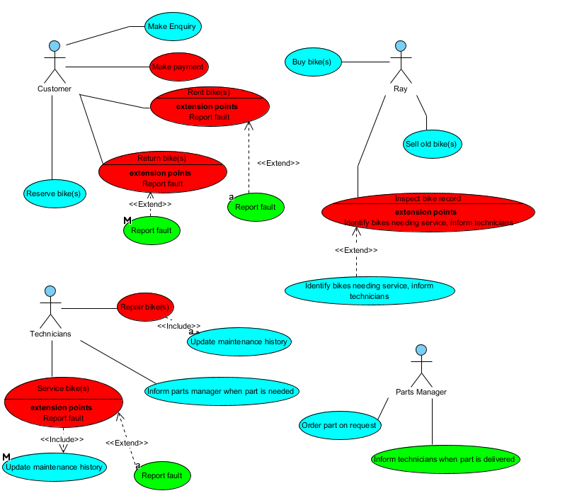

**Decisions Made Between Our Group**

The final UCD was created by Aubrey Monk with the help of group members and their individual UCDs. All actors on the final UCD are also on the group’s individual UCDs but there is one actor which has been taken off the final UCD.  
  
 Aubrey informed the group that the hiring department does a similar thing as the customer therefore it was removed since it would be repeating an actor with a different name. We have learned to use include and extend associations to link the actors and the cases together.

**Use Case Specifications**

|  |
| --- |
| **Use Case: *Make Enquiry (Aubrey Monk)*** |
| **Owner:** Customer |
| **Pre-Conditions** |
| A customer makes an enquiry over the phone to the hiring department to ask about a certain bike and it’s availability. |
| **Post-Conditions** |
| Information is given to the customer by the hiring department about a certain bike such as the price, model and availability or a document containing information about all the different types of bikes is emailed to the customer. |
| **Primary Path** |
| 1. Customer calls in for an enquiry about a certain bike. 2. If the bike is available then information about that bike is given to the customer by the hiring department. 3. Customer makes a decision to reserve the bike, rent the bike or enquire about a different bike. |
| **Alternate Path** |
| 1. The customer makes an enquiry about a certain bike that is not available. 2. The customer is informed when that bike is available. 3. The customer makes a decision to either reserve or rent the bike for a different date when it is available, or receive information about other available bikes via email. |
| **Notes** |
| N/A |
|  |
|  |

|  |
| --- |
| **Use Case: Rent Bike *(Scott Ng)*** |
| **Owner:** Customer |
| **Pre-Conditions** |
| A customer enters the shop to hire (rent) a bike with the hiring department. |
| **Post-Conditions** |
| The chosen bike’s availability will be updated to “occupied” and a new record will be made to log the hiring of the bike, including information such as the Customer ID, time hired, and Bike ID. |
| **Primary Path** |
| 1. Customer chooses to rent a bike. 2. A new record is made containing the details of the hiring (who hired the bike, for how long, how much was paid for the bike, which bike(s) were/was rented). 3. After allotted time, the bike is returned. 4. The record is updated by hiring department. |
| **Alternate Path** |
| 1. Customer hires pre-reserved bike. 2. A new record is made containing the details of the hiring (who hired the bike, for how long, how much was paid for the bike, which bike(s) were/was rented). 3. Record detailing the reservation is updated. 4. After allotted time, the bike is returned. 5. The rental record is updated by hiring department. |
| **Notes** |
| N/A |
|  |
|  |

|  |
| --- |
| **Use Case: *Service Bike (Henry Lee/Hai Yuan Lee)*** |
| Owner: Technicians |
| **Pre-Conditions** |
| Ray checks for any faults on the bikes and writes down all the bikes which are faulty and need repairing. A customer may report that the bike has a problem and needs fixing. |
| **Post-Conditions** |
| Technicians will fix the bike(s) if they have the parts in stock. If there are no parts, the technicians will need to contact the parts manager to get the missing parts. After the missing parts have arrived the bike will then be fixed and the maintenance records will be updated. |
| **Primary Path** |
| 1. Ray checks the bikes and find faults that can potentially be a safety hazard, and the customer may also report faults that they have been found on bikes they were using. 2. Ray will make a note of what needs to be fixed. The note is then sent to the technicians. 3. Bike is then fixed by the technicians and maintenance records is updated. 4. Bike is sent back to the shop. |
| **Alternate Path** |
| 1. Bike is reported to have a fault by the customer or Ray. 2. Ray makes a note of this and send it to the technicians along with the bike. 3. Technician needs to order new parts due to the part not being in stock. 4. Technician will make the repair and update the maintenance record once the part has arrived. 5. Bike is sent back to shop. |
| **Notes** |
| N/A |
|  |
|  |

|  |
| --- |
| **Use Case: *Order Part on Request (Zoheb Malik)*** |
| Owner: Parts Manager |
| **Pre-Conditions** |
| Technicians check if they have all parts to service/repair the bike, if they don’t they report it to parts manager who will then order the parts upon request. |
| **Post-Conditions** |
| The parts will arrive in stock and then the parts manager will inform the Technicians, they will then receive the parts and continue to repair/service the bikes. Everything will be restocked. |
| **Primary Path** |
| 1. Technicians check if they have the required parts. 2. Technicians need a part that isn’t in stock. 3. Parts manager are informed by technicians. 4. Parts manager orders parts. 5. Parts manager receives parts and informs technicians. |
| **Alternate Path** |
| 1. Technicians check if they have the required parts. 2. Parts manager informed by technicians if part is already in stock. 3. Parts manager has parts in stock, informs technicians. |
| **Notes** |
| N/A |
|  |
|  |

**Top Down ERD:**

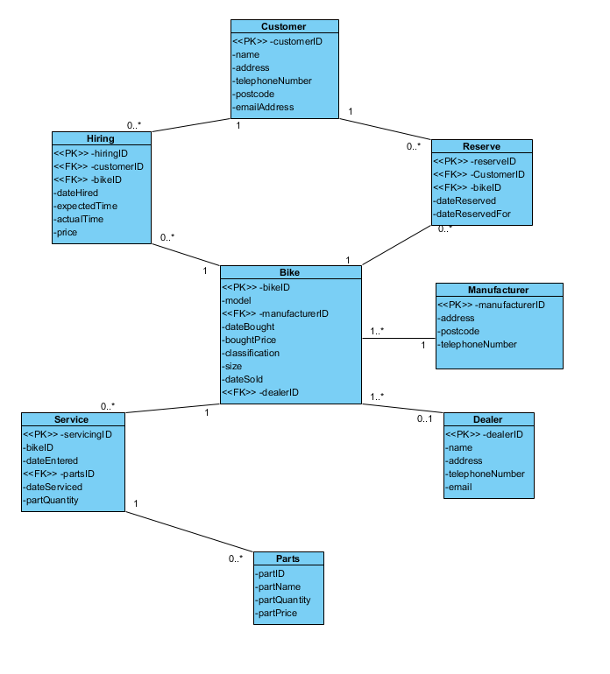

**Normalisation (RDA):**

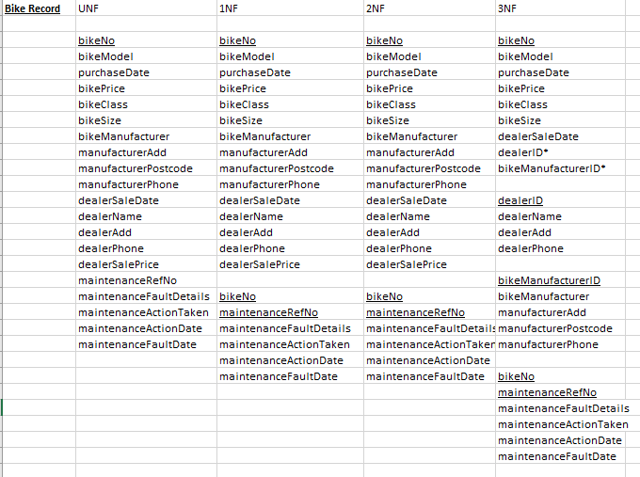

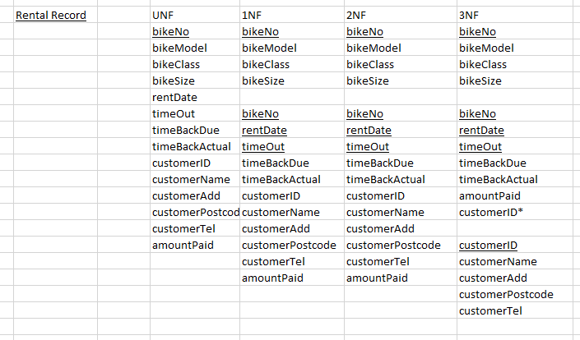

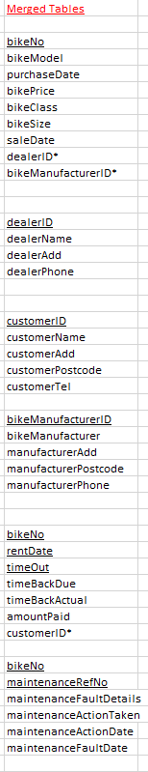

**Bottom Up ERD:**

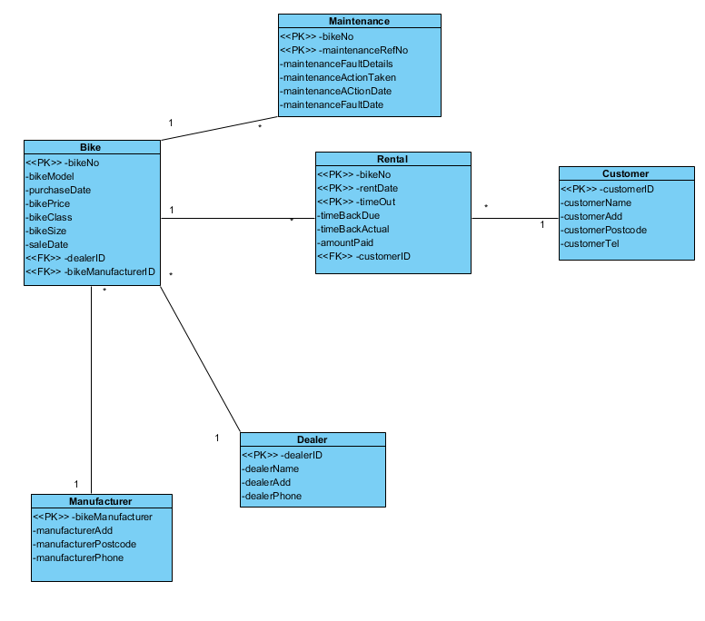

**Finalised ERD:**

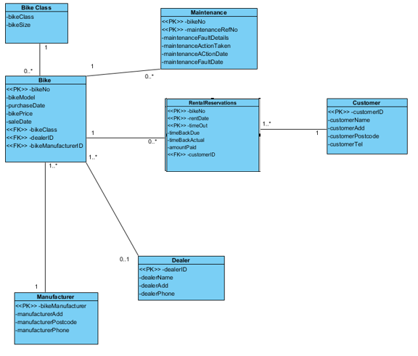

**Commentary explaining the decisions made when creating the finalised ERD and a summary of what has been learned in the process:**

When creating the final ERD I compared the bottom up and top down approaches and merged them together to form a coherent solution, one of the main issues I solved was the difference between reservations and rentals, to fixed this I created a bike class and merged the reservation and rentals tables together to form one table, a row in the table can partially be filled out to identify a reservation and fully filled out to identify a rental.

**Conclusion:**

In conclusion, throughout this report we have created a UCD(user case diagram) which is to help the group to figure out what are the roles of each department and staffs in ray’s rentals and what the customer usually do when contacting the shop. With this, we made a specification to be more detailed.

Furthermore we normalized (RDA) the records given by Ray’s Rentals, with this it will help us create our ERD ( Entity Relationship diagram ). We have completed top down ERD and bottom up ERD which is then used to create a finalised ERD. This will help us create our database further on in the year. Commentary on how we have done and the group decision on the UCD and ERD is done above on the report.

**Appendix:**

Zoheb’s UCD  
  
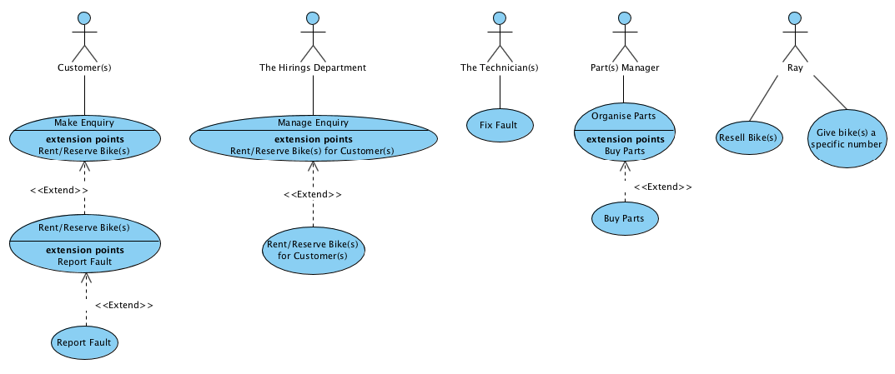

Aubrey’s UCD  
  
  
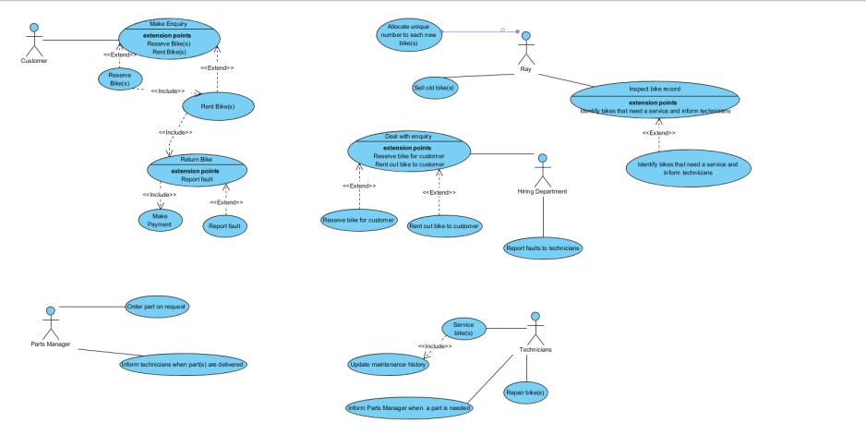

Scott’s UCD  
  
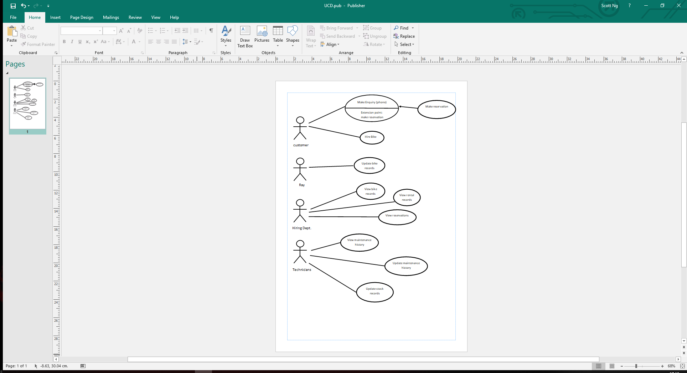

Henry’s UCD  
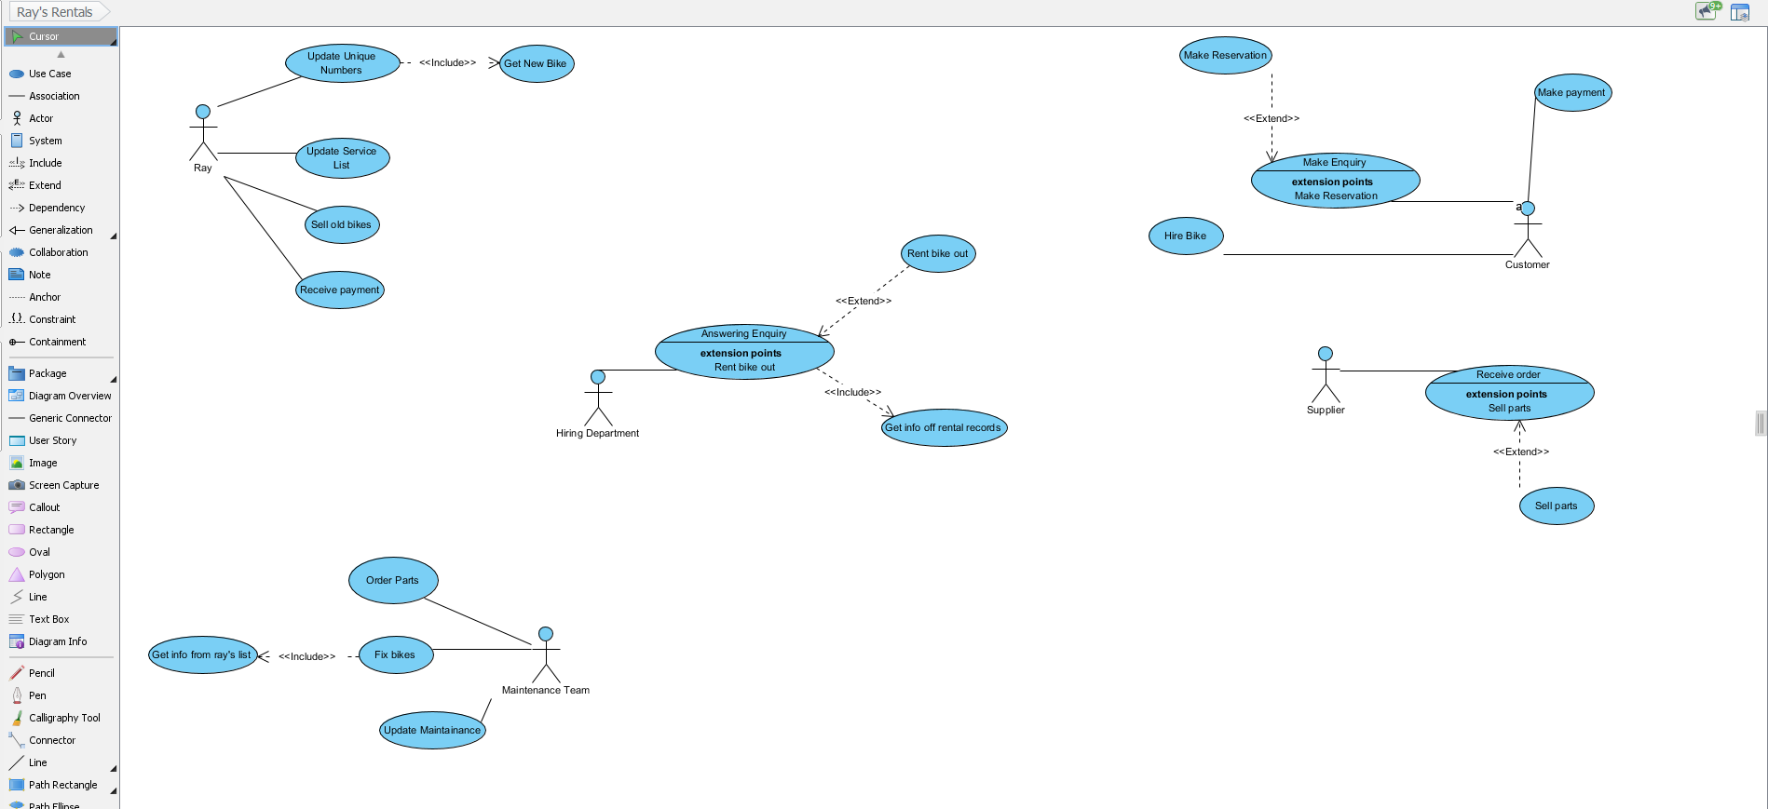

**Log Book ISRR part 2**

